Linux OS Assignment
Scenario
You are the primary responder for a suspected network breach. Before analysing the malicious files, you need to quickly set up a secure, isolated workspace on your terminal; lock down access so evidence isn't tampered with; and configure the firewall to block the attacker's command server.
Instructions
Complete the objectives below.
■ If you are using Kali Linux, Ubuntu, or a local VM: Complete all steps in your terminal.
■ If you are using Webminal (or a phone): Complete Objectives 1 and 2 in the terminal. Because you do not have the root privileges required to modify the host's firewall, complete Objective 3 by typing the correct commands into a text document instead.

Objective 1: File System Navigation & Creation
1. Navigate to your home directory and create a new main directory called quarantine_zone.
2. Inside quarantine_zone, create three new directories: pcap_logs, malware_samples, and threat_intel.
3. Create a new, empty file named suspect_ips.txt inside the threat_intel directory.
4. Copy the suspect_ips.txt file into the pcap_logs directory.

Objective 2: Securing Evidence (Permissions)
1. The suspect_ips.txt file contains sensitive attacker data. Modify its permissions so that the owner can read and write, the group can only read, and others have absolutely no access.
2. Write down the command you would use to change the group ownership of the quarantine_zone directory to a group named soc_analysts (assume this group has already been created on the system).

Objective 3: Network Isolation (Firewall)
1. Write the command to check the current status of your firewall (assume ufw).
2. Write the command to explicitly deny all incoming traffic from the attacker's IP address: 198.51.100.22.
3. Write the command to allow incoming traffic on Port 443 so your team can securely pull threat intelligence feeds.
4. Write the command to enable the firewall.

Deliverables for Grading
Submit a document containing the following:
■ Screenshots of the exact commands you typed for every step in Objectives 1, 2, and 3.

■ A screenshot showing the final permissions of suspect_ips.txt using the ls -l command.
■ Local/VM Users: A screenshot showing your active firewall rules.
■ Webminal Users: Your written commands for Objective 3 clearly labelled.

If you’re submitting with a link, ENSURE YOU GRANT ACCESS.
If you use pictures of your screen, instead of screenshots, you’ll be graded 0.
Deadline: Wednesday, 26th August 2026, 8:30PM.

ANSWER
As the instruction says starting from the Objective 1 stated below:
File System Navigation & Creation
1. Navigate to your home directory and create a new main directory called quarantine_zone.
2. Inside quarantine_zone, create three new directories: pcap_logs, malware_samples, and threat_intel.
3. Create a new, empty file named suspect_ips.txt inside the threat_intel directory.
4. Copy the suspect_ips.txt file into the pcap_logs directory.
So, I navigated through as shown below in the screenshot
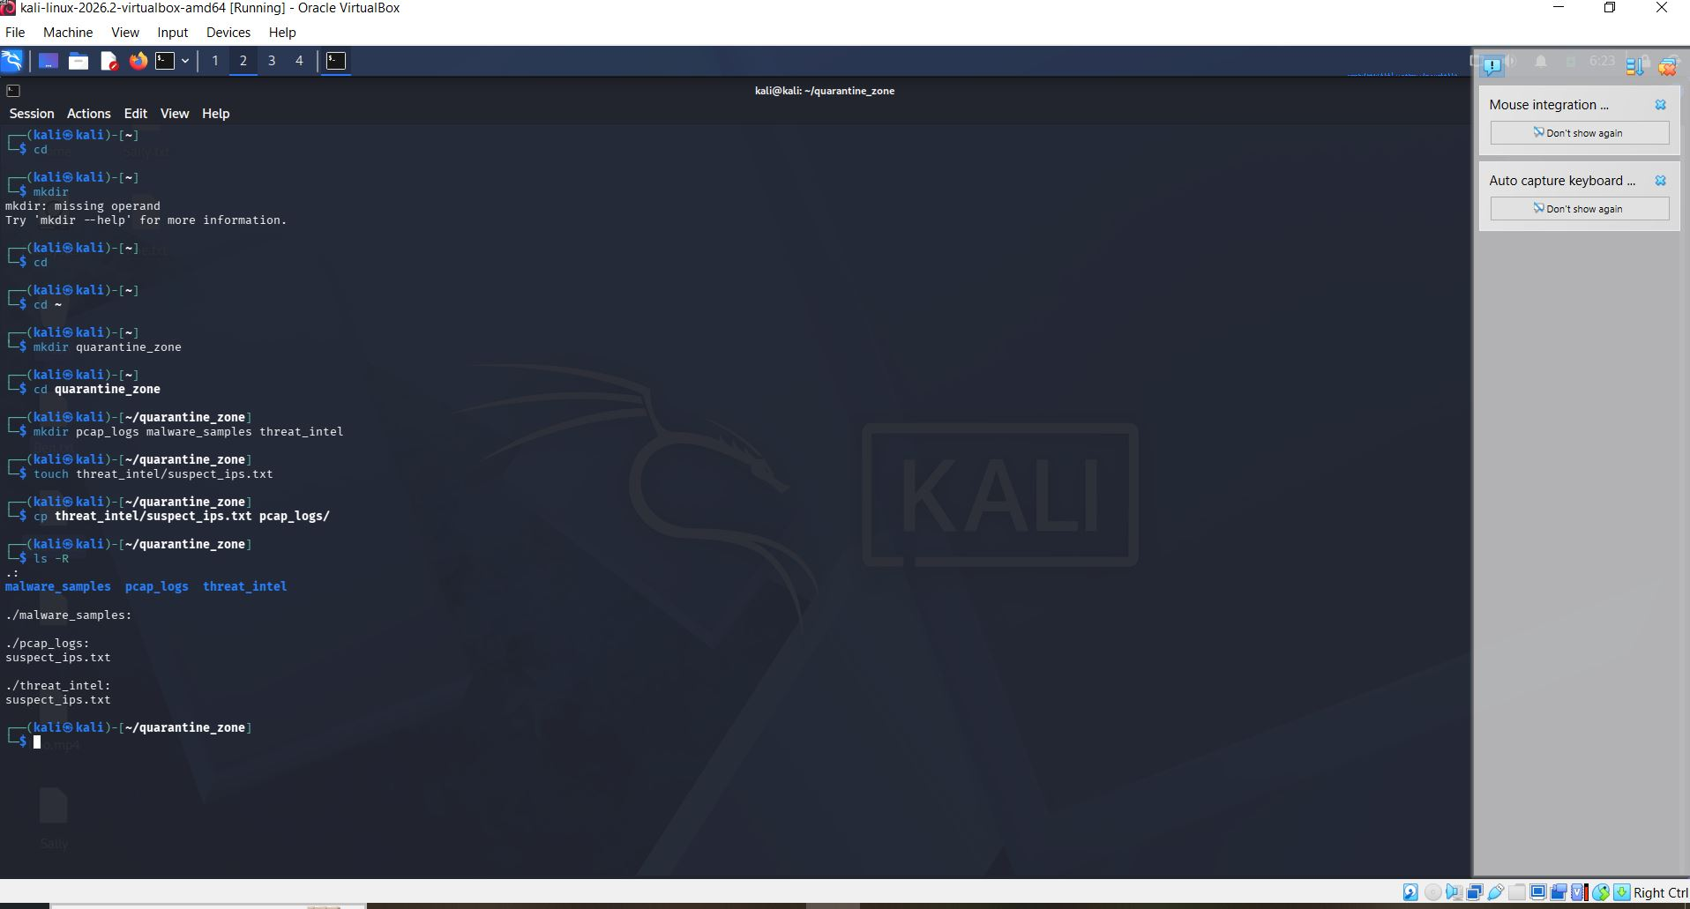

Then, I navigated to the objective 2 as stated below
Securing Evidence (Permissions)
1. The suspect_ips.txt file contains sensitive attacker data. Modify its permissions so that the owner can read and write, the group can only read, and others have absolutely no access.
2. Write down the command you would use to change the group ownership of the quarantine_zone directory to a group named soc_analysts (assume this group has already been created on the system).
BUT CAN ALSO USE THIS COMMAND “chown :soc_analysts quarantine_zone”
This is an alternative to what I used in the screenshot below.
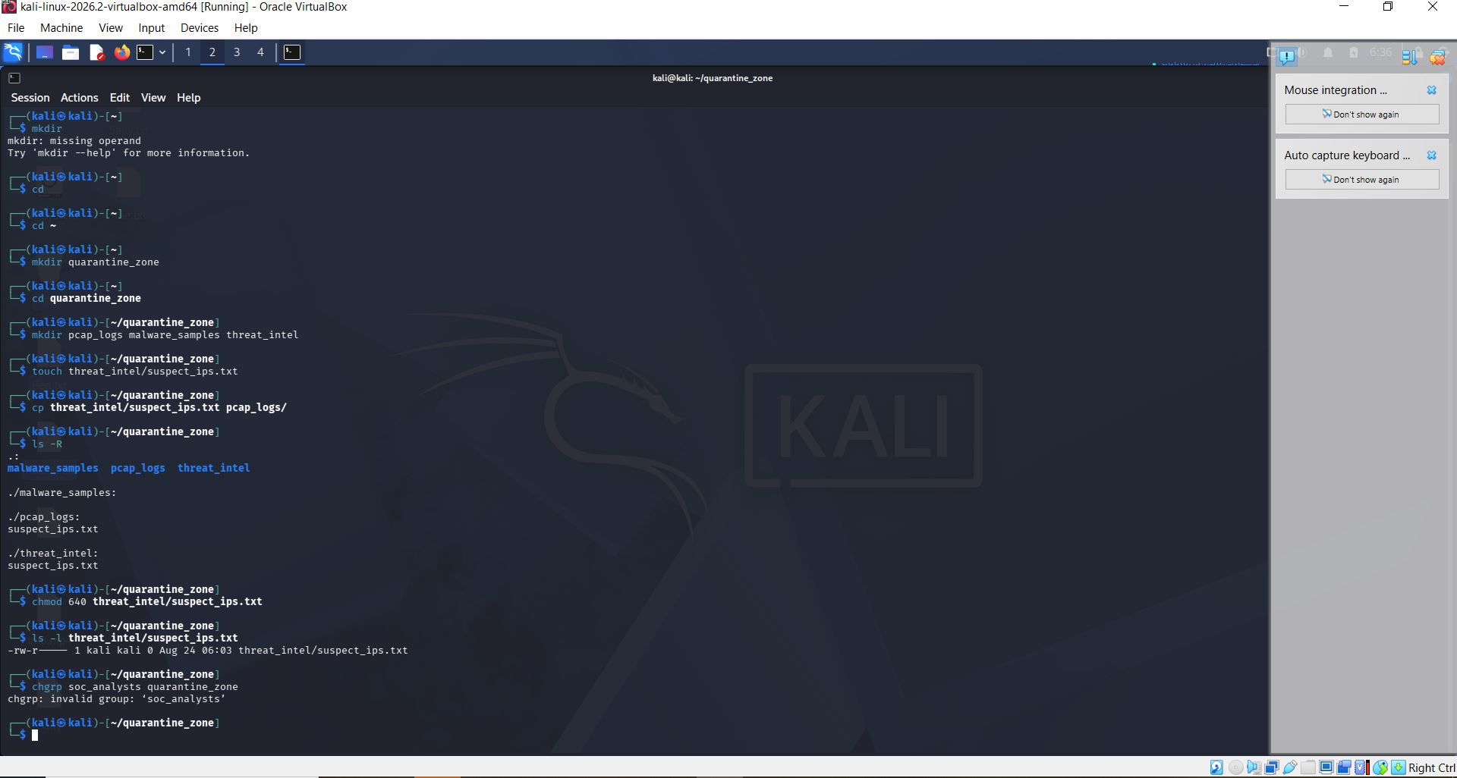

Finally, I used the commands to isolate and block the IP address 198.51.100.22 and also allowing incoming traffic in Port 443. As detailed below
Network Isolation (Firewall)
1. Write the command to check the current status of your firewall (assume ufw).
2. Write the command to explicitly deny all incoming traffic from the attacker's IP address: 198.51.100.22.
3. Write the command to allow incoming traffic on Port 443 so your team can securely pull threat intelligence feeds.
4. Write the command to enable the firewall.
All shown in the screenshot below



